- Look at the photos and answer the questions:
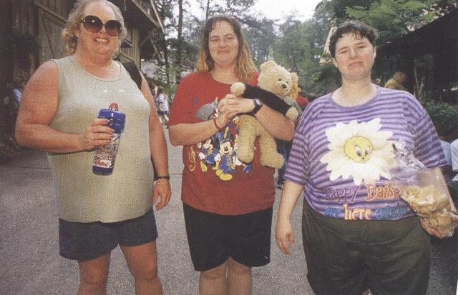
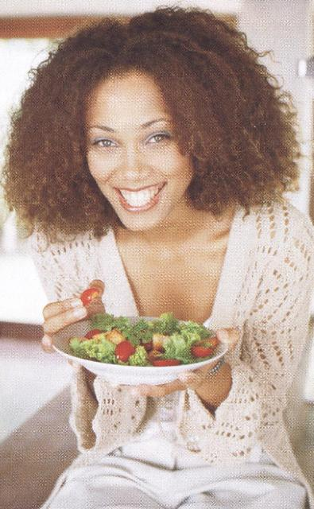

Answer the questions (give the full answers)
How do the lifestyles and eating habits of these women differ?
What eating disorders may each of them suffer from?
Which of them is healthier? Why?
Why do so many people now give up meat and become vegetarians?
Do you think your everyday diet is healthy? Explain.
What should people do if they want to lose weight?
Have you ever been on a diet? Describe it.

2. Talk about your family food traditions using the following prompts.
Our usual meals are ....
The chief meal of the day is ...
My usual breakfast is ...
I generally gave lunch at ....
On weekdays I eat at/in ... , my parents ... my brother/sister ...
I usually have ...
At weekends we ..
We have dinner at ...
It consists of ....
For festive dinners we cook ...
Our special dish is ...

